PREPROPOSAL SITE VISIT RECORD
FOXHOUND Recreation Center HVAC renewal
SOLICITATION / ORDER: SM-SABER-01 request for Task Order 27-041
DATE / TIME: 28 April 2027 | 0930-1100 Alaska time
LOCATION: Bldg 410, FOXHOUND Recreation Center
LEAD: Capt Mei Chen, Contract Specialist, 713 CONS
The Government escorted prospective task-order participants around the exterior and interior work areas. The route included the eastern service yard and exterior wall, both personnel entrances, the auditorium, the mechanical service zone, and the proposed equipment path. Attendees were permitted to take photographs and ask written follow-up questions through the Contracting Officer.
Attendee | Organization | Role | Signature
Capt Mei Chen | 713 CONS | Contract specialist / site-visit lead | /s/ Mei Chen
Dr. Hal Emmerich | 713 CES | Chief facilities engineer | /s/ Hal Emmerich
Alex Torres | 713 FSS | Recreation Center facility manager | /s/ Alex Torres
Robin Hale | Outer Heaven Builders, LLC | Project manager | /s/ Robin Hale
Avery Stone | Outer Heaven Builders, LLC | Proposed superintendent | /s/ Avery Stone
Nadia Rahal | Zanzibar Mechanical and Controls, LLC | Estimator / mechanical lead | /s/ Nadia Rahal
RECORD NOTE. Outer Heaven Builders attended the full route. No attendee reported a drawing/site discrepancy concerning the two former eastern vehicle bays before proposal submission.
Certified as the contemporaneous attendance record:
/s/ Mei Chen | Capt, USAF | 713 CONS | 28 April 2027

SITE-VISIT PHOTOGRAPH
Eastern service-yard elevation | Photograph 3 of 7
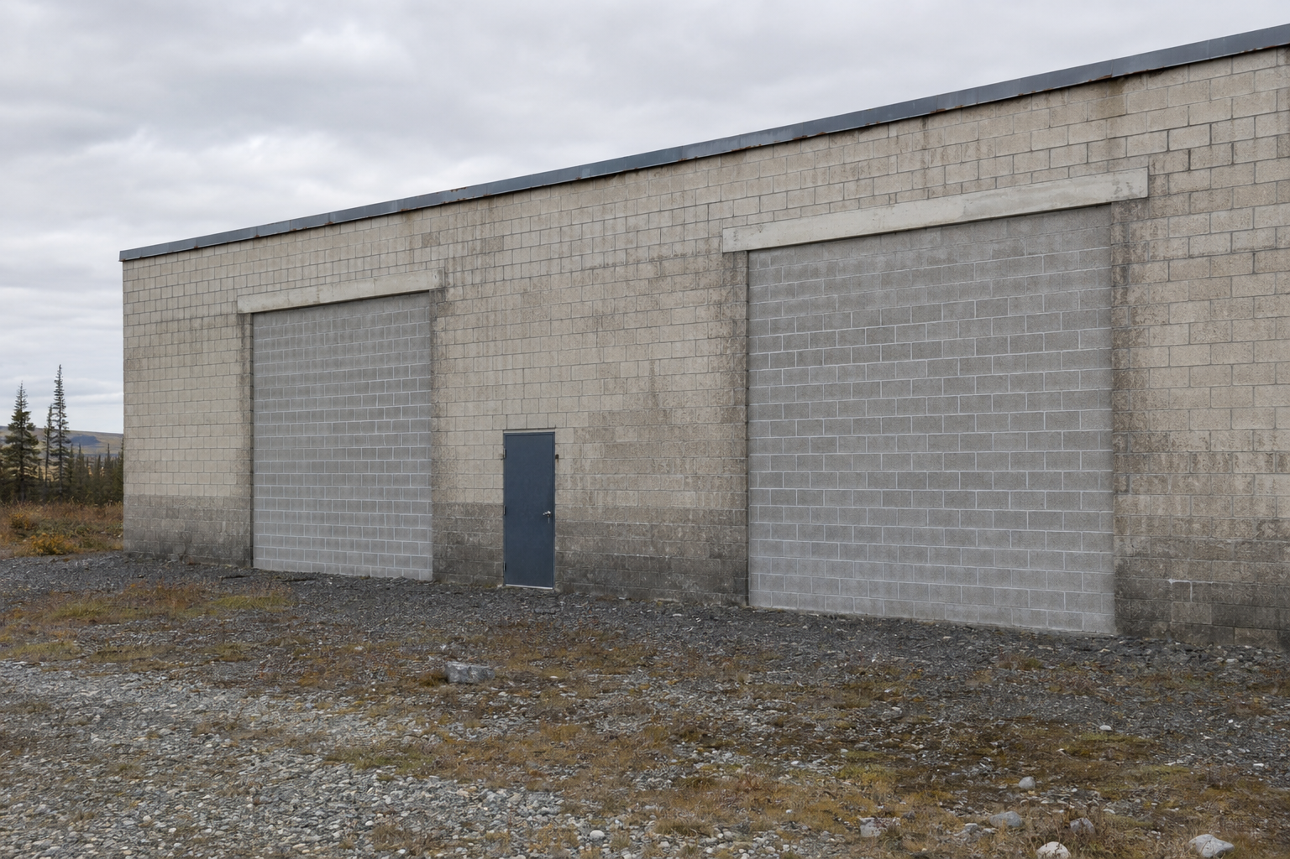
VIEW: Exterior east wall of Bldg 410, photographed from the service yard at 1008 on 28 April 2027. Two large former vehicle-bay openings are visibly infilled with contrasting masonry; the retained lintels and opening outlines are apparent. The personnel door between them provides scale.
Photograph taken by Capt Mei Chen during the site visit and retained with the attendance record. No markings have been added to the image. The scene, photograph, and record are fictional and exist only for this training exercise.

