DEPARTMENT OF THE AIR FORCE
SHADOW MOSES AIR FIELD, ALASKA
COR PHYSICAL-INSTALLATION CONCERN
Payment Request No. 005 - period ending 20 August 2027
Task order | FA-27-005 - Campbell Hall Phased Headquarters Renovation
Prime contractor | Peace Walker Infrastructure Partners, LLC
Field verification | 20 August 2027; memorandum completed 26 August 2027
Government verifier | 1st Lt Jack 'Raiden,' on-site COR, 713th Civil Engineering Squadron (713 CES)
Review basis | Visible and inspected field installation; COR daily reports 27-68; field photographs D03-01 through D03-03

COR comparison
Work portion | Scheduled value | Claimed | Installed | Claimed value | Installed-only
Electrical | $3,200,000 | 65% | 52% | $2,080,000 | $1,664,000
HVAC | $4,000,000 | 60% | 30% | $2,400,000 | $1,200,000
Drywall | $1,600,000 | 25% | 0% | $400,000 | $0
TOTAL | $8,800,000 |  |  | $4,880,000 | $2,864,000

COR observations
• Electrical - 52% installed: Panels, feeders, branch conduit and related accepted work are present, but the visible and quantity-verified installation does not appear to support the contractor's 65-percent schedule entry.
• HVAC - 30% installed: The east equipment and initial distribution run are present, while west and branch distribution remain uninstalled. Field installation appears to support 30 percent rather than the claimed 60 percent.
• Drywall - 0% installed: No metal framing or gypsum-board installation had begun in the scheduled drywall areas by the period cutoff, although the contractor claims 25 percent.
• Review limitation: This memorandum compares the request with installed construction observed in the field. The COR did not reconcile the claimed percentages to the accepted progress schedule, schedule of values, or material-delivery records.
COR RECOMMENDATION: The claimed value exceeds the installed-only field estimate by $2,016,000. Withhold that amount from Payment Request No. 005 unless the Contracting Officer determines that another contract-authorized basis supports it.
Prepared and signed by | Signature | Date
1st Lt Jack 'Raiden'  On-site COR, 713 CES | /s/ Jack Raiden | 26 Aug 2027
This memorandum records the COR's field observations and recommendation. The Contracting Officer determines the approved progress-payment estimate under the contract.
FIELD PHOTOGRAPH LOG
COR evidence - 20 August 2027
The three exercise images below are the dated photographs cited in the COR inspection log and marked during the 26 August record review.
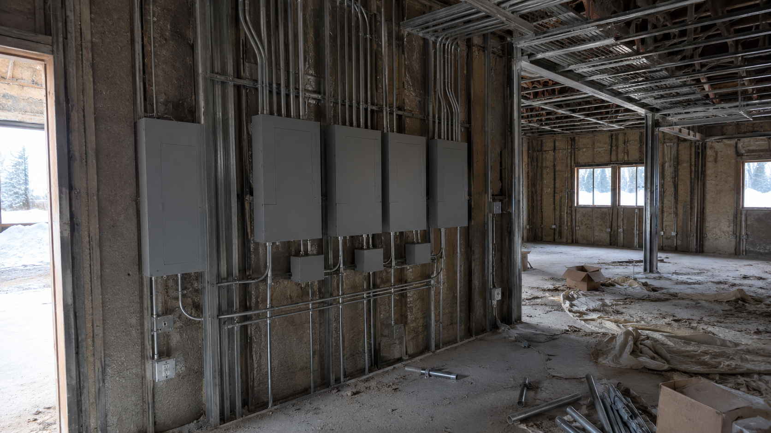
D03-01 - Electrical. Panels, feeders and branch-conduit work installed in Gallery E-14. COR field estimate: 52% installed versus 65% claimed. COR mark: /s/ Jack Raiden, 26 Aug 2027.
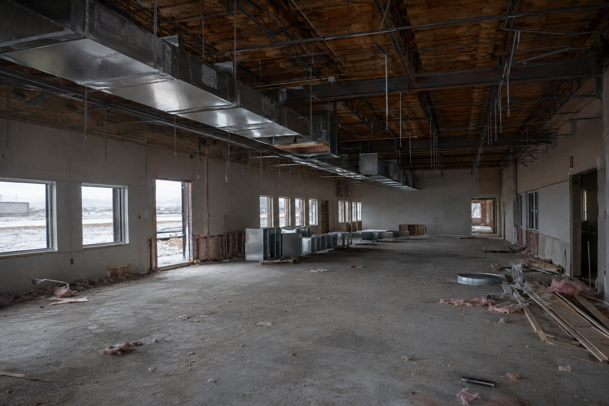  D03-02 - HVAC. Only the east main distribution run is installed; empty hangers continue west. COR field estimate: 30% installed versus 60% claimed. COR mark: /s/ Jack Raiden, 26 Aug 2027. | 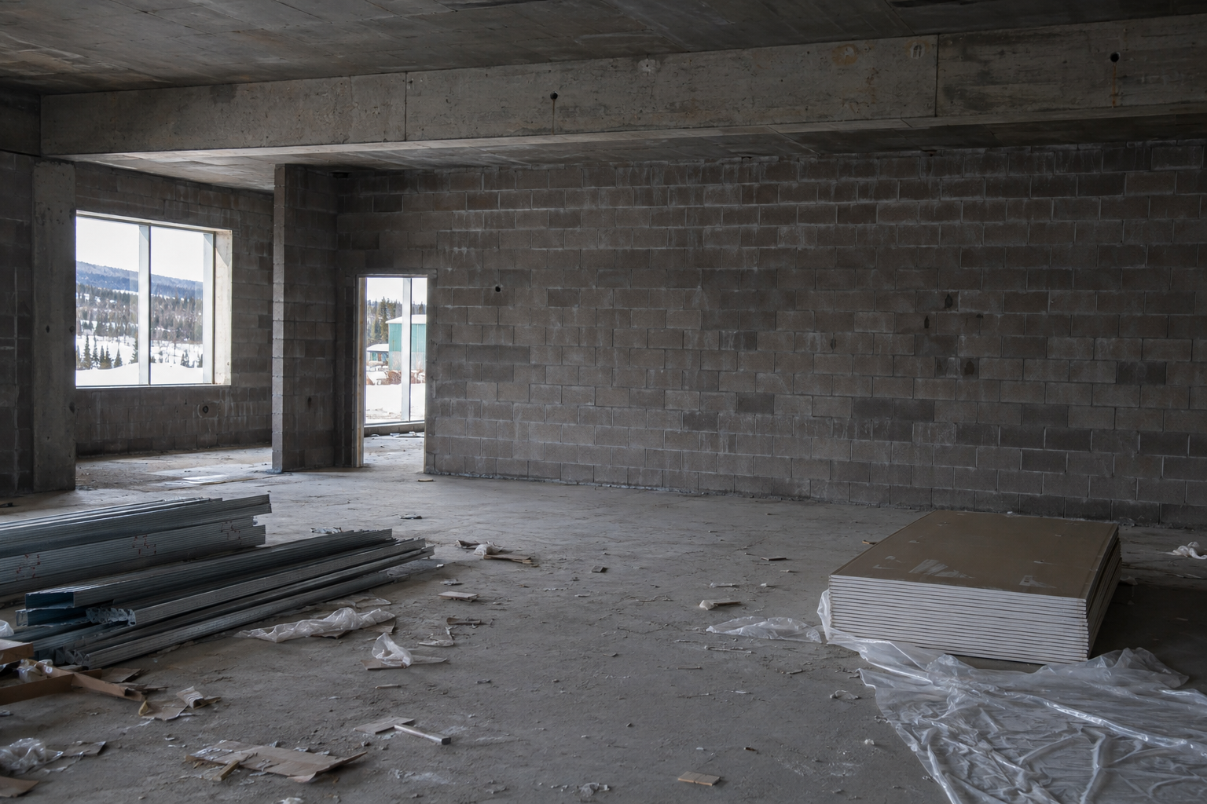  D03-03 - Drywall. Scheduled corridor remains bare with no metal framing or gypsum-board installation. COR field estimate: 0% installed versus 25% claimed. COR mark: /s/ Jack Raiden, 26 Aug 2027.
PHOTO RECORD: Original image identifiers, dates, locations and observations are cross-referenced to COR Inspection Log 27-063. Images are fictional and provided solely for this training exercise.

