COMMAND POST DESIGN-BUILD PROPOSAL
Diamond Dogs Civil Works, LLC | CP-27-008 | Submitted 21 July 2027
OFFEROR STATEMENT. Mission resilience through an integrated secure-operations design
Firm-fixed price | $8,615,000
Calendar duration | 410 days from notice to proceed
Proposed turnover | 29 September 2028 · 16 days before required date
Proposal validity | 120 calendar days
Design responsibility | Complete post-award design and construction by the design-builder
Boulder stand-off | North 62 ft · East 74 ft · South 58 ft · West 36 ft from the corresponding exterior wall

Executive approach
Diamond Dogs Civil Works, LLC offers one integrated design-build team for Building 100. The concept addresses 24/7 operations, secure communications, cold-region envelope performance, resilient utilities, controlled access, and fixed site-security barriers while retaining the existing footprint. Its boulder perimeter is 62 feet north, 74 feet east, 58 feet south, and 36 feet west of the corresponding exterior walls.

Response to stated evaluation factors
Factor | Offeror response
Technical approach | Exceptional. Central operations floor; secure rooms along the east service spine; public entry south; controlled service entry east. Two energy-recovery air handlers and three 50-percent hydronic boilers provide maintainable redundancy. Sectionalized distribution, a 150 kVA UPS, and two 300 kW generators support continuous operations.
Management approach | Very Good. One accountable manager; integrated submittal register; weekly discipline coordination; quality-control and safety gates.
Schedule | Very Good. 410 days; turnover 29 September 2028; 16 days of stated contingency.
Key personnel | Dedicated program manager, design manager, and superintendent identified below.
Past performance | Three comparable records supplied with quality, timeliness, and cost-control context.
Price | Firm-fixed price of $8,615,000 for complete design, construction, commissioning, training, and closeout.

Principal strengths
- Most resilient mechanical and electrical concept.
- One-model design-management plan with weekly discipline clash reviews.
- Strongest key-personnel depth and most relevant secure-facility record.
CONCEPT DESIGN
Offeror-developed floor, systems, and security layout · not construction documents
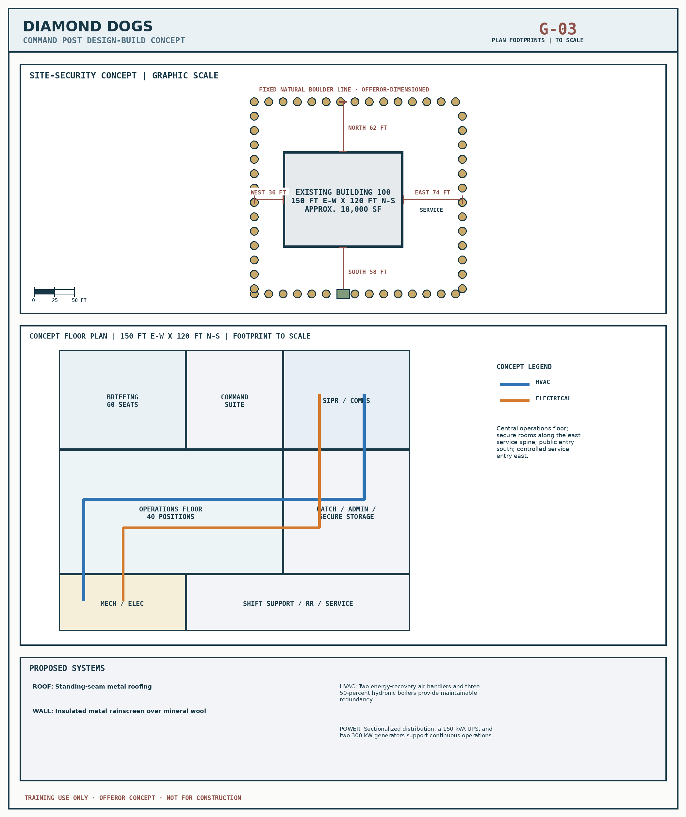
DESIGN STATUS. This is a concept-level submission. Final dimensions, calculations, grading, utilities, foundations, anchorage, and construction details will be developed after award through the required design reviews.
MANAGEMENT AND SCHEDULE
Design-construction integration and proposed control plan

Management approach
- One program manager controls price, schedule, design, construction, subcontracts, and Government correspondence.
- A common design model, submittal register, and weekly meeting link architectural, structural, civil, mechanical, electrical, communications, security, fire, and commissioning disciplines.
- Preparatory, initial, and follow-up quality-control phases precede each definable feature; safety planning and activity-hazard analysis are integrated into release decisions.
- Long-lead equipment is released after accepted design information; field verification precedes demolition and fabrication.

Key personnel
Individual | Role and qualifications
Dana Rourke, PE | Program Manager · 14 years remote vertical construction
Samuel Hideo, AIA | Design Manager · 11 secure operations facilities
Marcus Flint | Superintendent · 9 Alaska projects without lost-time injury

Proposed schedule
Milestone | Date / period | Control
Notice to proceed | 16 Aug 2027 | Baseline and field verification begin.
35% design | 22 Sep 2027 | Confirm floor, site, systems, and long-lead basis.
65% design | 20 Nov 2027 | Resolve coordination before broad construction release.
95% design | 19 Jan 2028 | Complete systems and commissioning requirements.
Final design | 16 Feb 2028 | Issue accepted construction package.
Construction | Oct 2027 – Aug 2028 | Envelope, interiors, systems, security, and sitework.
Commission / train | Aug – Sep 2028 | Testing, training, punch list, and closeout.
Offeror turnover | 29 September 2028 | 16 days before 15 Oct 2028.
PAST PERFORMANCE AND PRICE
Quality, timeliness, cost control, and firm-fixed-price offer

Relevant record
Project | Value | Quality | Timeliness | Cost control
North Radar Support Facility | $7.40M | Very Good | 12 days early | Good; 0.8% Government-change growth
Fort Raven Secure Operations Center | $9.20M | Exceptional | On time | Exceptional; absorbed coordination rework
SM-MACC-01 Generator Annex | $5.85M | Very Good | 6 days early | Very Good; 0.4% growth
The Government may verify the records above and consider relevance, context, and trend. All project names and performance records in this exercise proposal are fictional.

Firm-fixed-price breakout
Item | Price element | Amount
1 | Design, surveys, management, bonds, and controls | $905,000
2 | Roof and exterior envelope | $1,465,000
3 | Interior renewal and mission spaces | $1,766,000
4 | Electrical, emergency power, and communications pathways | $1,465,000
5 | HVAC, plumbing, fire protection, and life safety | $905,000
6 | Site security, boulders, entries, drainage, and restoration | $862,000
7 | Commissioning, training, closeout, and remote logistics | $646,000
8 | Offeror contingency and price balance | $601,000
 | TOTAL FIRM-FIXED PRICE | $8,615,000
OFFER. Diamond Dogs Civil Works, LLC offers the complete requirement for $8,615,000, firm fixed price, subject to SM-MACC-01 and CP-27-008.
AUTHORIZED OFFEROR: /s/ Dana Rourke, PE, for Diamond Dogs Civil Works, LLC
DATE: 21 July 2027

