MSF CONSTRUCTION JV - REVISED BARRIER CONCEPT
Response to Amendment 0001 | West-side fire-lane coordination | 12 August 2027
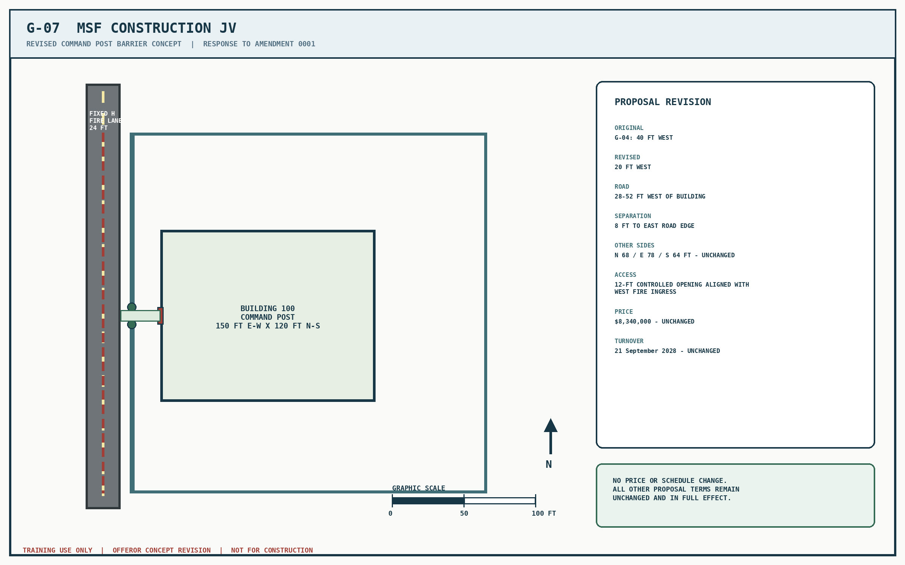
This sheet revises only the west barrier alignment. All other portions of the offeror's original proposal remain unchanged.

