COMMAND POST + FIRE-LANE COMPOSITE PLAN
Original G proposal perimeters over fixed H road alignment | Common graphic scale | 4 August 2027
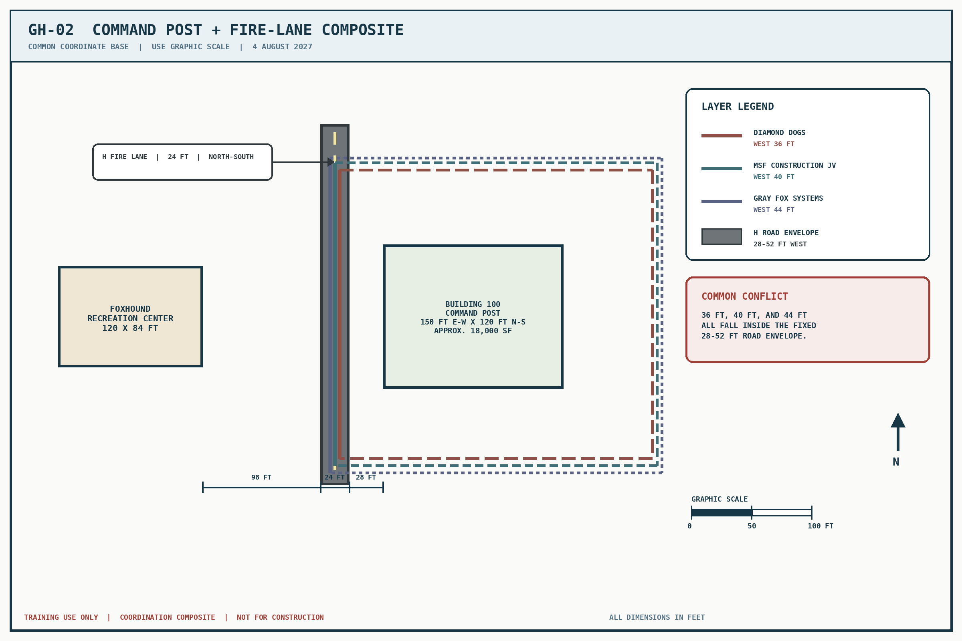
Prompt-only coordination record. Release when trainees ask to overlay G and H or compare the proposal offsets with the road alignment.

