FIRE-LANE ALIGNMENT + TURNING PLAN
FL-27-014 | Government reference geometry | 20 July 2027
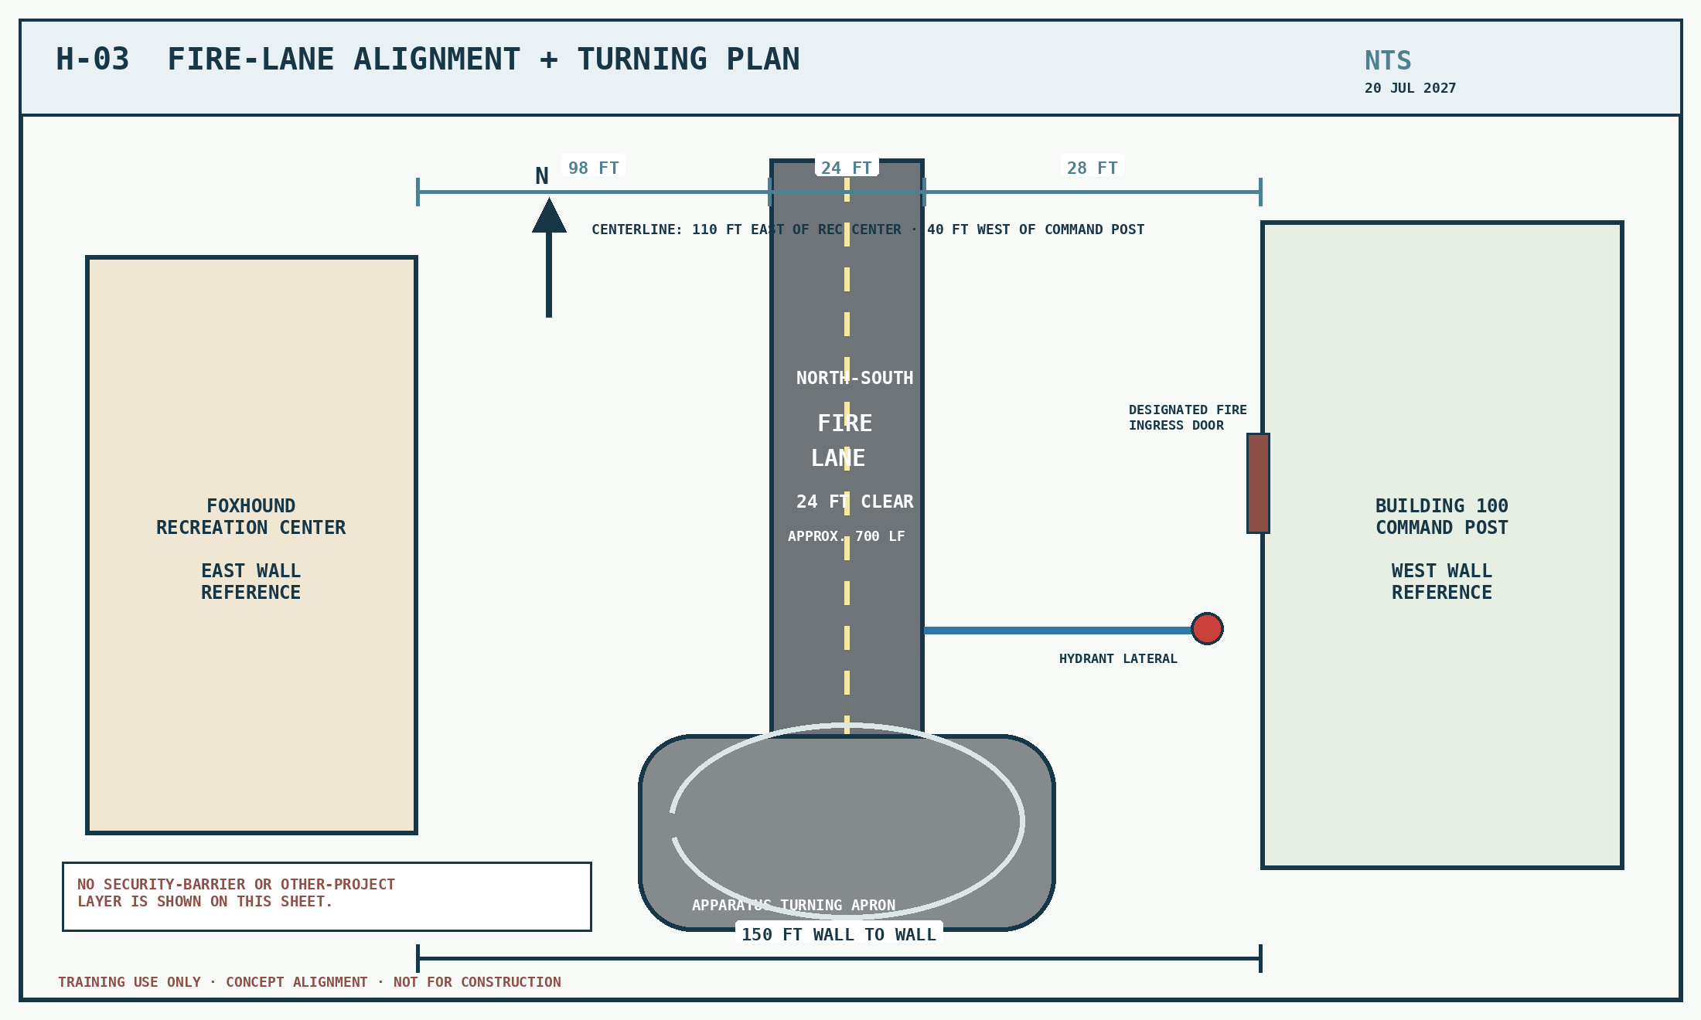
Fixed alignment: use with H-02 and H-04. Any cross-project overlay is a separate, prompt-only coordination record.

