713TH CIVIL ENGINEER SQUADRON

INSTALLATION PHOTOGRAPH AND GOVERNMENT USE RECORD
Campbell Hall Office 214
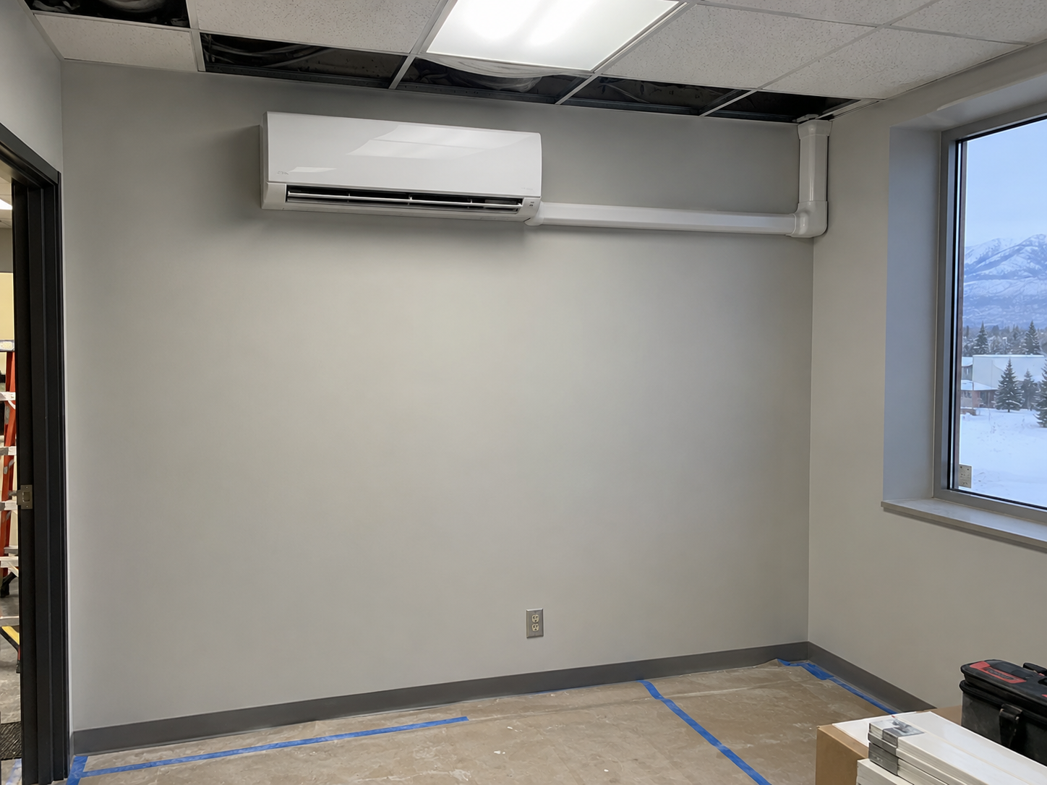
Photograph 1. Office 214 indoor unit on 14 August 2027 after installation and before final room turnover.
RECORD | FINDING | DATE AND SOURCE
Installation | Wall unit, line-set cover, circuit, disconnect, condensate, and seals present | 14 Aug | CES field photo
Functional test | Heating, cooling, controls, defrost, and condensate checks passed | 15 Aug | startup sheet
Government use | Unit placed in service and used for Office 214 environmental control | Since 16 Aug | facility log
Technical inspection | Installed work is acceptable and may remain in place | 18 Aug | CES Mechanical Systems
Record conclusion The Government received and continues to use a technically acceptable system. This record establishes benefit and condition; it does not decide authority, liability, price reasonableness, or ratification.
/s/ HAL EMMERICH
Hal Emmerich
Mechanical Engineer, 713 CES
18 August 2027

