DEPARTMENT OF THE AIR FORCE
SHADOW MOSES AIR FIELD, ALASKA
AWARDED DESIGN EXTRACT
Task Order FA-27-005 | Campbell Hall Phased Headquarters Renovation
Drawing | M-214 — Level 2 Mechanical Plan, Office 214
Design status | Issued for Construction — 10 March 2027
Contractor | Peace Walker Infrastructure Partners, LLC
Purpose | Identify the mechanical work included in the awarded task order
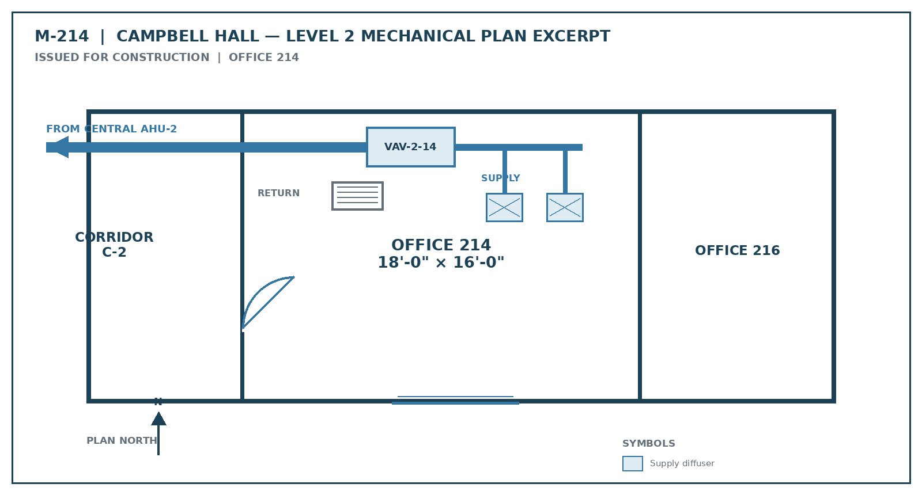
DRAWING CONTROL: This is an extract of the Government-issued, awarded design. It depicts Office 214 served by the building's central system through VAV-2-14. Interpret it together with the equipment schedule and scope extract on page 2.

SCOPE AND EQUIPMENT CROSS-CHECK
Awarded records for Office 214

Task-order scope extract
CLIN 0001 requires phased renovation of Campbell Hall, including renewal of central air-handling equipment, terminal units, duct distribution, controls, electrical distribution, interior finishes, and commissioning. Office 214 is shown as an ordinary administrative office served by AHU-2 and VAV-2-14. New equipment must appear in the issued drawings, specifications, equipment schedule, or an authorized written modification.
TAG | AWARDED EQUIPMENT | AREA SERVED | DRAWING / SPEC
AHU-2 | Central air-handling unit | Campbell Hall Level 2 | M-201 / 23 73 00
VAV-2-14 | Variable-air-volume terminal unit | Office 214 and adjacent zone | M-214 / 23 36 00
EF-2-3 | Restroom exhaust fan | Level 2 restrooms | M-214 / 23 34 23
CU-1 | Telecommunications-room cooling unit | Room 208 only | M-208 / 23 81 26

Drawing and specification index
RECORD | DESCRIPTION | OFFICE 214 RESULT
M-214 | Level 2 mechanical plan | Central supply and return through VAV-2-14
M-601 | Mechanical equipment schedule | No dedicated split-system equipment scheduled for Office 214
E-214 | Level 2 power plan | No dedicated circuit, disconnect, or outdoor-unit feed for Office 214
23 81 26 | Split-system air-conditioning specification | Applies only where equipment is scheduled; Office 214 is not listed
CONTRACT-FILE FINDING: The awarded task order contains no dedicated mini-split for Office 214. The installed system invoiced in IG-01 is therefore extra-contractual work unless a Contracting Officer later authorized it by written modification. No such pre-installation modification exists in the file.
/s/ HAL EMMERICH
Hal Emmerich
Chief Facilities Engineer, 713 CES
18 August 2027

