DEPARTMENT OF THE AIR FORCE
SHADOW MOSES AIR FIELD, ALASKA
DAILY INSPECTOR REPORT EXTRACTS
Campbell Hall electrical subcontract work - 23 August through 10 September 2027
Prime / subcontractor | Peace Walker Infrastructure Partners, LLC / Volgin Electrical Services, LLC
Task order | FA-27-005 - Campbell Hall Phased Headquarters Renovation
Government inspector | Meryl Silverburgh, Construction Inspector, 713 CES
Named crew | Elena Cruz, Marcus Hale, Tariq Benson, and June Park
Record basis | Daily reports 27-069 through 27-083; photographs K05-01 and K05-02

Consolidated daily-report entries
Dates | Crew / hours | Observed work | Location / record
23-27 Aug | 4 named workers  40 hours each  160 total | Measured, cut, bent, supported, and installed EMT raceway and conduit; installed pull boxes; pulled branch conductors. | Level 1 east corridor and Electrical Gallery E-14  Reports 27-069 to 27-073
30 Aug-3 Sep | 4 named workers  40 hours each  160 total | Installed conduit fittings and equipment boxes; pulled feeder and branch conductors; mounted de-energized panel equipment. | Level 1 central corridor and Mechanical/Electrical Room 118  Reports 27-074 to 27-078
6-10 Sep | 4 named workers  40 hours each  160 total | Continued raceway and conductor installation; mounted devices and panel components; made de-energized terminations under the electrical foreman. | Level 2 west offices and Panel Room 214  Reports 27-079 to 27-083
TOTAL | 4 workers  120 hours each  480 total | No general cleanup, nonspecialized excavation, or material-handling-only shift was recorded for these workers during the period. | Three complete workweeks
INSPECTOR ATTESTATION: The entries above are accurate extracts of my contemporaneous daily reports. They describe who was present, the hours observed or reconciled to the site log, and the work underway; they do not state a wage-classification conclusion.
Signed | Name / position | Date
/s/ Meryl Silverburgh | Meryl Silverburgh  Construction Inspector, 713 CES | 13 Sep 2027
SITE PHOTOGRAPH RECORD
Exercise images cited in daily reports 27-076 and 27-081
The photographs are training simulations of the documented conditions. They are paired with the inspector's written identification of the named crew; no facial identification is required from the images themselves.
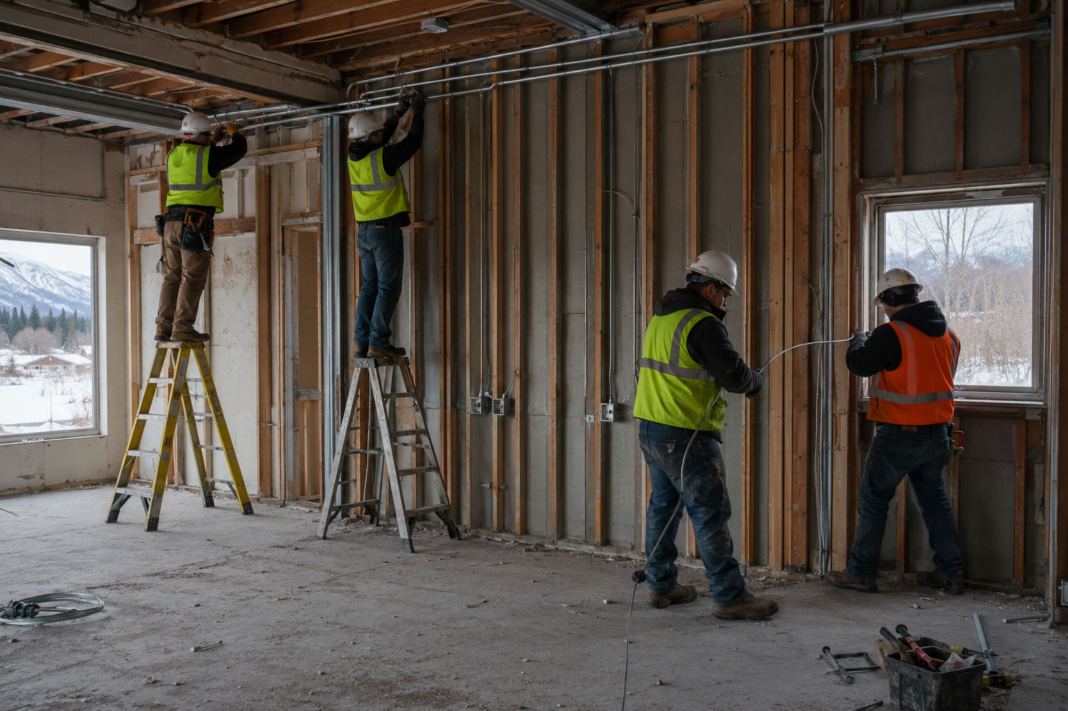
K05-01 - 1 SEP 2027 / 1015: Level 1 central corridor. Inspector log identifies Cruz, Hale, Benson, and Park installing supported metal raceway and pulling conductors under Volgin's electrical foreman. Camera: Government inspection tablet; file hash recorded in report 27-076.
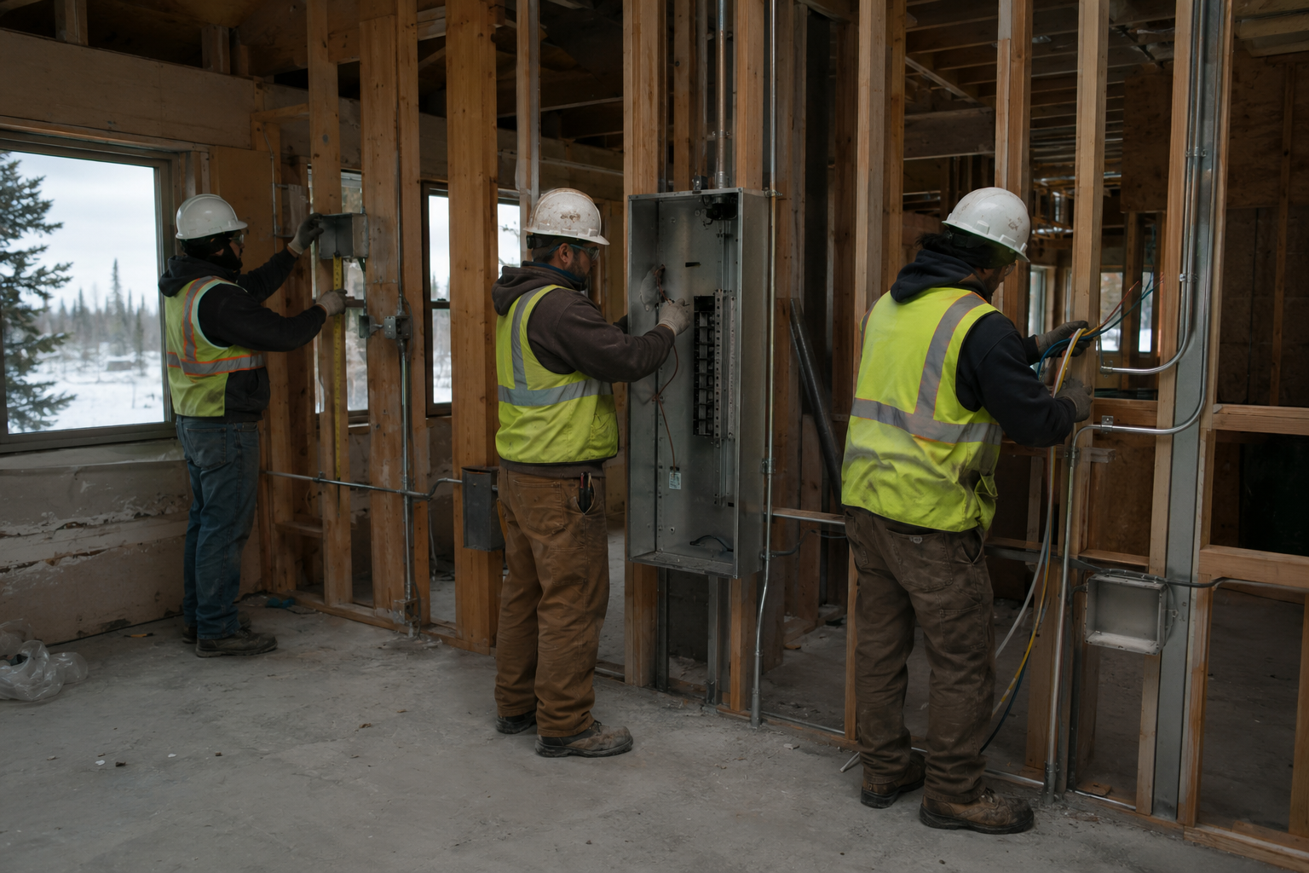
K05-02 - 8 SEP 2027 / 1340: Panel Room 214. Three visible members of the same four-person crew are mounting electrical boxes and panel components and making de-energized terminations; the daily report records all four workers on site. Camera: Government inspection tablet; file hash recorded in report 27-081.

