OUTER HEAVEN BUILDERS, LLC
SHADOW MOSES AIR FIELD, ALASKA
ROOFING DAILY-REPORT EXTRACT
Mother Base Community Support Center | 1-16 September 2027
Contract | SM-SABER-01 Task Order 27-064 - Community Support Center Roof Replacement
Prime / roofing sub | Outer Heaven Builders, LLC / Diamond Dogs Roofing, LLC
Report source | Contractor daily reports DR-09-01 through DR-09-16
Extract purpose | Record reported field conditions and work interruption on the eleven claimed dates

Claimed interruption entries
Date | Entry | Planned activity | Reported field condition / result
1 Sep | DR-WX-01 | Existing membrane removal | Full roofing shift stopped; wet surface and standing water
2 Sep | DR-WX-02 | Insulation removal / deck exposure | Full roofing shift stopped; wet deck could not be exposed
3 Sep | DR-WX-03 | Deck preparation | Full roofing shift stopped; water remained in low areas
7 Sep | DR-WX-04 | Vapor-retarder placement | Full roofing shift stopped; substrate remained damp
8 Sep | DR-WX-05 | Insulation placement | Full roofing shift stopped; materials kept covered
9 Sep | DR-WX-06 | Membrane installation | Full roofing shift stopped; surface water continued
10 Sep | DR-WX-07 | Membrane installation | Full roofing shift stopped; adhesion conditions not met
13 Sep | DR-WX-08 | Membrane seams / flashing | Full roofing shift stopped; rain and wet work surface
14 Sep | DR-WX-09 | Perimeter and curb flashing | Full roofing shift stopped; standing water at drains
15 Sep | DR-WX-10 | Roof dry-in progression | Full roofing shift stopped; work area remained wet
16 Sep | DR-WX-11 | Roof dry-in progression | Full roofing shift stopped; rain during planned shift
RECORD LIMIT: These entries corroborate that roofing was interrupted on the listed dates. They do not compare actual weather with historical or contract-anticipated conditions and do not establish critical-path effect, timely notice, concurrency, or mitigation.
/s/ Mara Vance | Quality Control Manager, Outer Heaven Builders, LLC | 20 Sep 2027

OUTER HEAVEN BUILDERS, LLC
SHADOW MOSES AIR FIELD, ALASKA
SELECTED PHOTOGRAPHIC LOG
Daily-report images furnished with the prime contractor's extension request
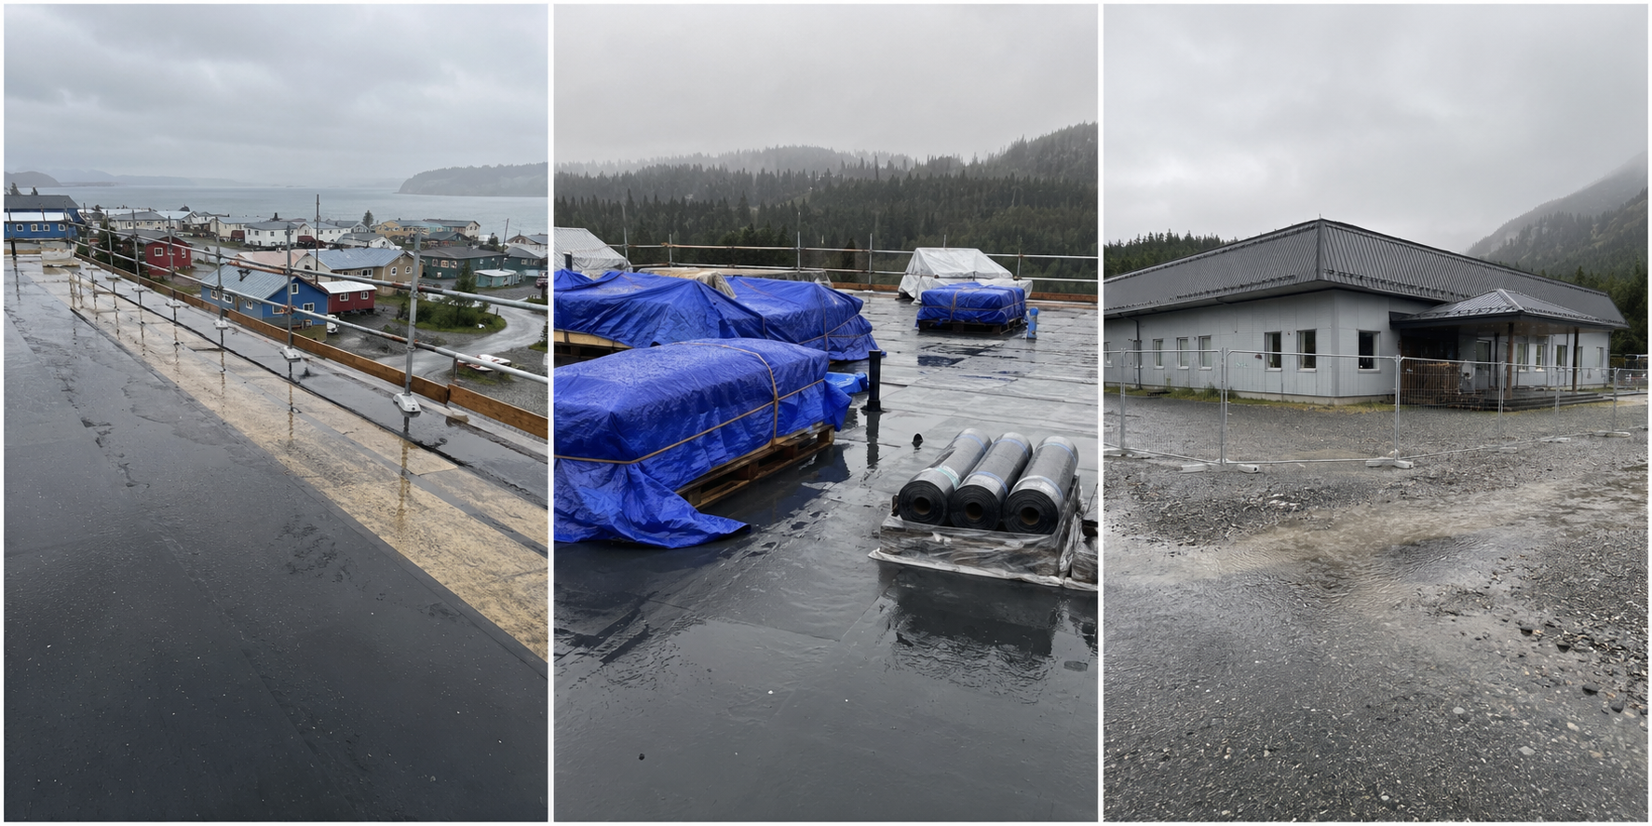
Left to right: partially stripped roof with standing water; secured roofing materials on a wet work surface; Community Support Center exterior during a roofing pause.
Photo record | Daily-report caption
DR-PH-0903 / 3 Sep 2027 | Standing water across the active roof work zone; membrane-removal work stopped.
DR-PH-0909 / 9 Sep 2027 | Insulation and membrane materials secured beneath tarps; installation work stopped.
DR-PH-0916 / 16 Sep 2027 | Facility exterior and fenced work area during rain; roof crew remained off the work surface.
EVIDENTIARY LIMIT: The photographs support the presence of wet conditions and paused work. Their dramatic appearance does not establish that the weather was unusually severe or that any date caused excusable, nonconcurrent critical-path delay.
Record note: Exercise images are fictional and generated for this training scenario; no real facility, contractor, or classified material is depicted.

