INSTALLATION ORIENTATION | SIMPLIFIED SITE PLAN
SHADOW MOSES AIR FIELD - SIMPLIFIED INSTALLATION MAP
Operation NORTHERN LANTERN | Program Month 3
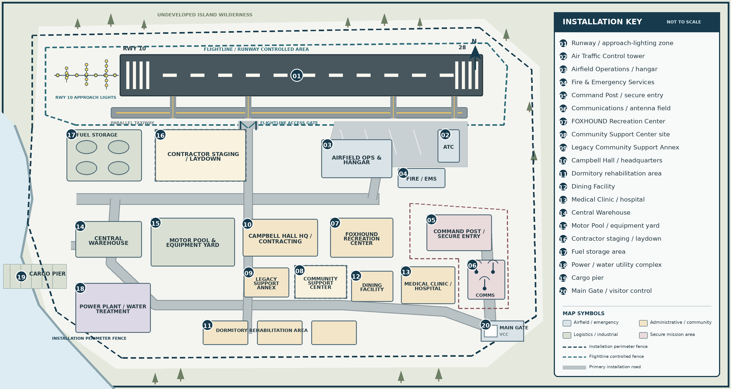
QUICK ORIENTATION
NORTH | AIRFIELD  Runway / approach lights, taxiway, flightline gate, ATC, hangar, and Fire / EMS. | SOUTH | CANTONMENT  Headquarters, recreation, community support, dormitories, dining, and medical. | WEST | LOGISTICS  Cargo pier, fuel, warehouse, motor pool, utilities, and contractor staging. | EAST | MISSION / ENTRY  Command Post, communications area, and the Main Gate / visitor control.
MAP USE: General orientation only; not to scale. Facility footprints and routes are simplified and do not establish contract requirements, site conditions, access rights, utility locations, or construction limits. Request project-specific drawings, surveys, access plans, and overlays when those facts are needed.

