DEPARTMENT OF THE AIR FORCE
SHADOW MOSES AIR FIELD, ALASKA
SIPR ROOM POSSESSION BOUNDARY PLAN
Building 100 | Task Order FA-27-008 | Effective 10 September 2028
Possessed portion | Room 1-126 and controlled access segment shown by blue dashed line
Remaining project | All rooms and work outside the dashed line remain in contractor control
Condition location | Wall A-17, broad north interior wall of Room 1-126
Plan basis | Accepted Diamond Dogs final design; 150-ft east-west x 120-ft north-south footprint
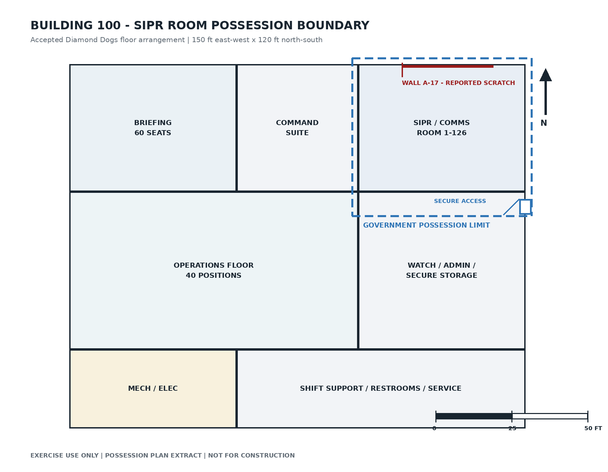
Blue dashed line: Government possession limit. Red line: reported Wall A-17 scratch location. North is up.
PLAN LIMIT: This drawing identifies the portion in Government use. It does not show when the wall condition occurred or constitute inspection or acceptance of the depicted work.

