DEPARTMENT OF THE AIR FORCE
SHADOW MOSES AIR FIELD, ALASKA
PRE-POSSESSION CONDITION RECORD
SIPR Room 1-126 | Joint inspection immediately before Government use
Inspection | 10 September 2028 / 0615-0648 Alaska time
Possession effective | 10 September 2028 / 0700 Alaska time
Government participants | Dr. Hal Emmerich, 713 CES; Maj Meryl Silverburgh, Command Post Operations
Contractor participant | Dana Rourke, PE, Diamond Dogs Civil Works, LLC
Photo record | CP-UP-0097 / captured 0642 / original file retained in CES project record
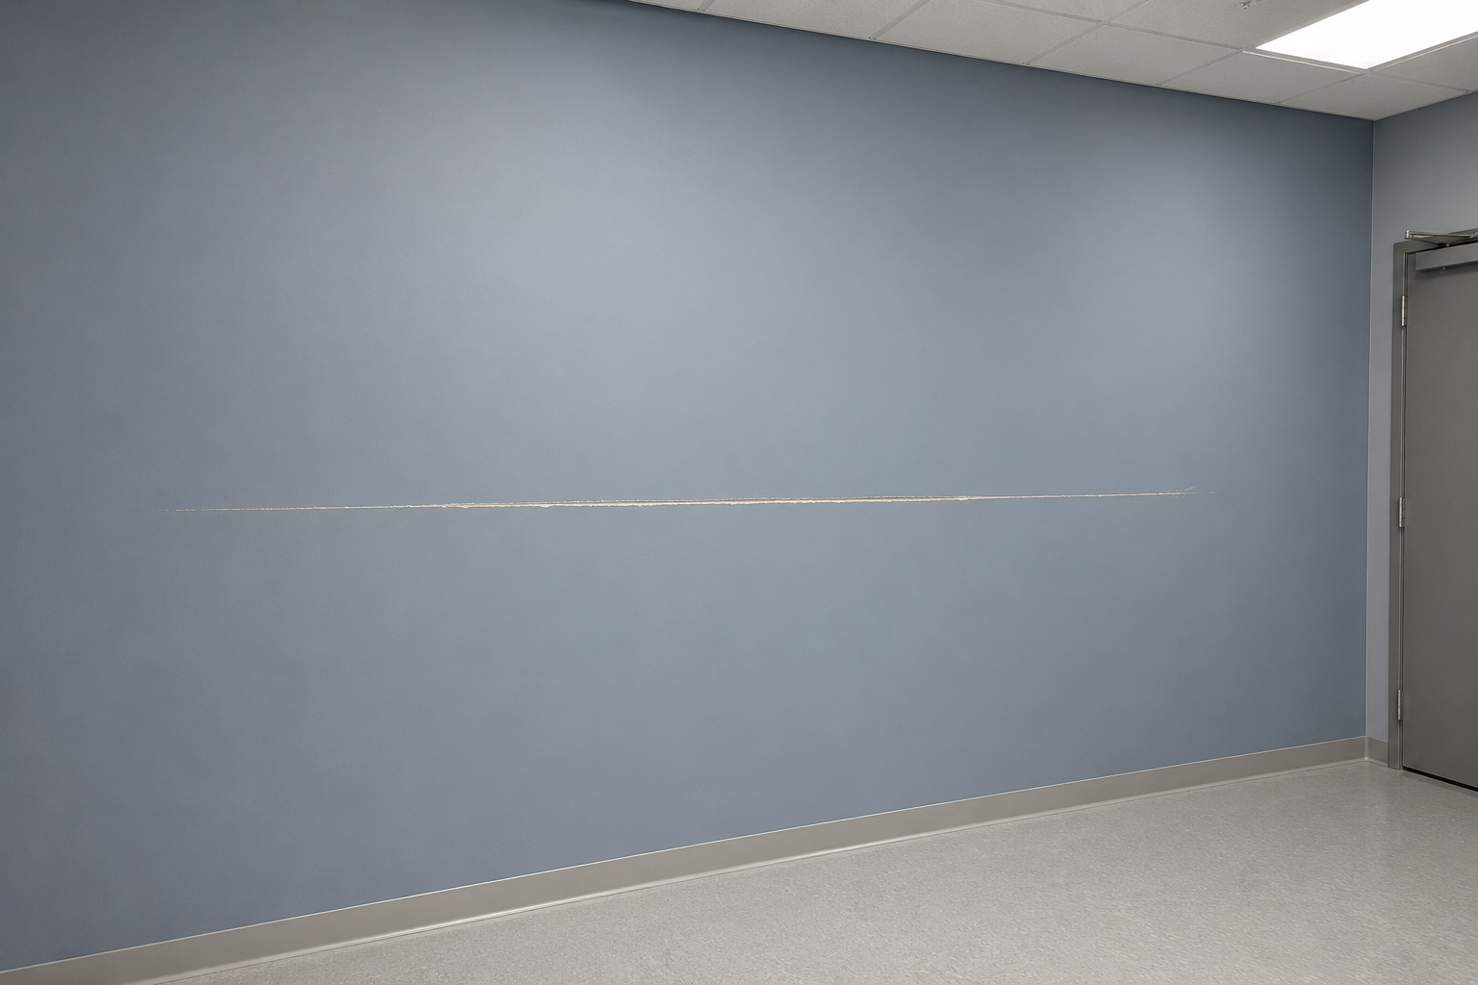
Photo CP-UP-0097 - Wall A-17 at 0642 on 10 Sep 2028, eighteen minutes before Government possession.
Condition item | Joint record
Wall A-17 | Horizontal scratch visible before possession; approximately 58 in long and 44 in above finished floor
O-01 transcription | Wall A-17 repair was not transferred to the Contracting Officer's remaining-work list
Room status | Unoccupied at capture; keys and operational custody transferred at 0700
Record note: SHA-256 b90de52d5d084eb5...62b357b5537eb42c. Exercise image generated for this scenario; no real facility or classified material is depicted.
/s/ Hal Emmerich | Government inspection lead, 713 CES | 10 Sep 2028

